**Table of Contents**

**Task1** 2

**A** 2

**B** 3

**C** 4

**Task2** 5

**A** 5

**B** 9

**C** 10

**D** 11

**E** 12

**F** 14

**G** 15

**H** 15

**I** 15

**J** 15

**K** 16

**L** 16

**M** 16

**N** 17

**O** 17

**P** 17

# **Task1**

## **A**

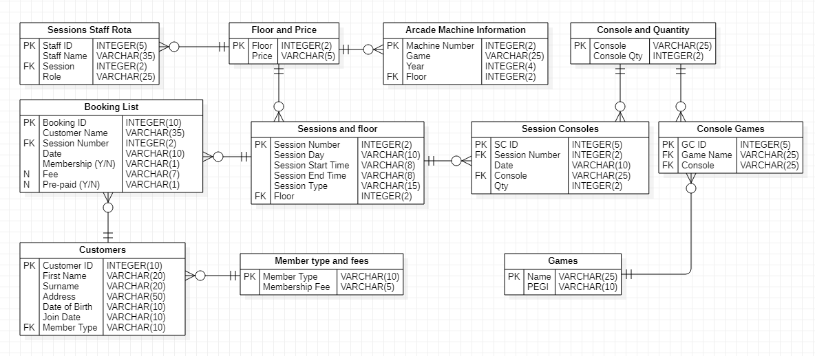

Figure 1: ER Diagram

## **B**



Figure 2:Normalization

## **C**



Figure 3: Data Dictionary

# **Task2**

## **A**

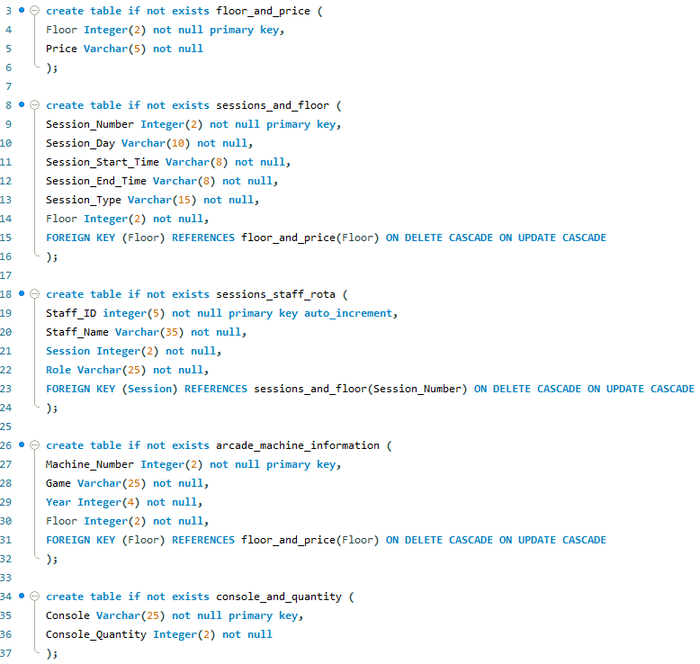

Figure 4:Creating Table SQL Scripts

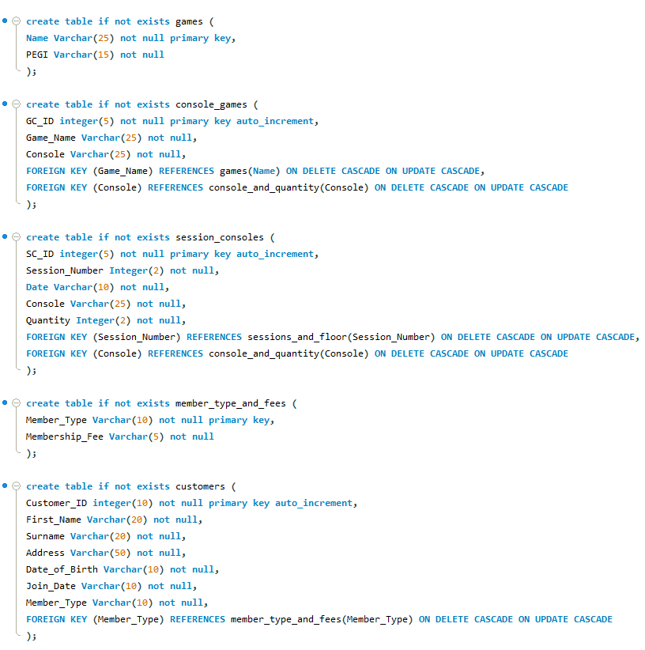

Figure 5: Creating Table SQL Scripts

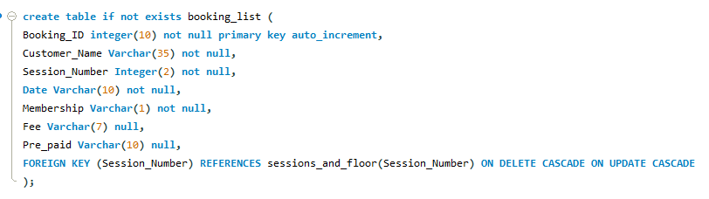

Figure 6: Creating Table SQL Scripts

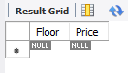

Figure 7: Floor and Price Table

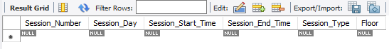

Figure 8: Session and Floor Table

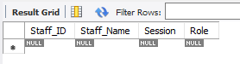

Figure 9: Session Staff Rota Table

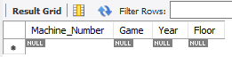

Figure 10: Arcade Machine information Table



Figure 11: Console and Quantity Table

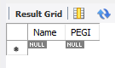

Figure 12: Games Table

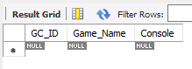

Figure 13: Console Games Table

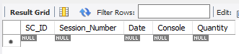

Figure 14: Session Console Table

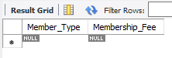

Figure 15: Member Type and Fees Table

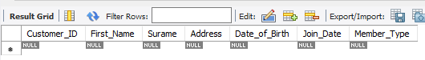

Figure 16: Customers Table

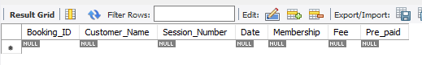

Figure 17: Booking List Table

## **B**

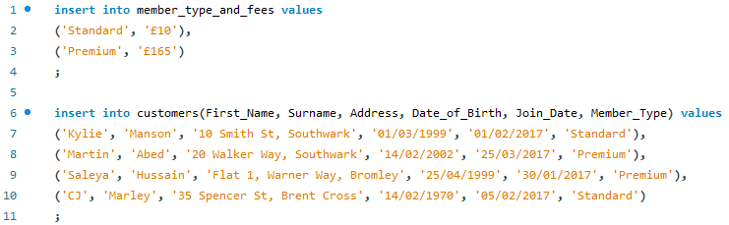

Figure 18: Inserting data on customers and member types tables

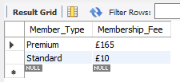

Figure 19:Member Type and Fees Table

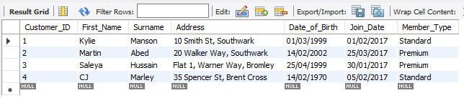

Figure 20: Customers Table

## **C**

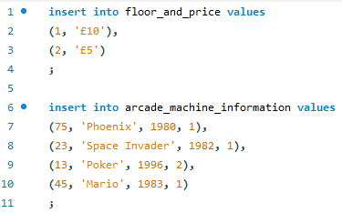

Figure 21: Inserting data on the machines and floors tables

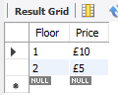

Figure 22: Floor and Price Table

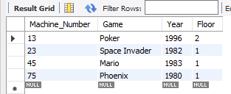

Figure 23: Arcade Machine information Table

## **D**

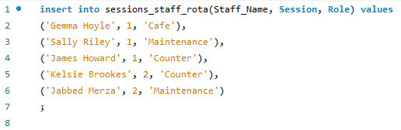

Figure 24: Inserting data on the staff rota table

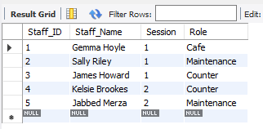

Figure 25: Session Staff Rota Table

## **E**

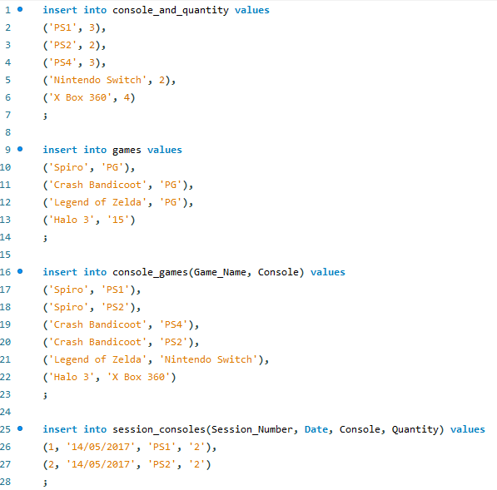

Figure 26: Inserting games and console data

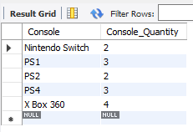

Figure 27: Console and Quantity Table

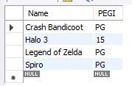

Figure 28: Games Table

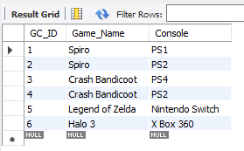

Figure 29: Console Games Table

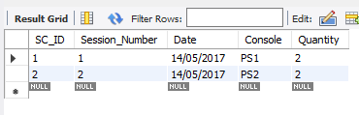

Figure 30: Session Console Table

## **F**

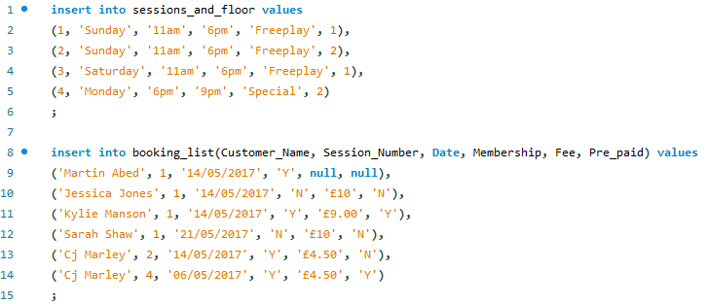

Figure 31: Inserting Session Data

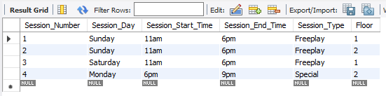

Figure 32: Session and Floor Table

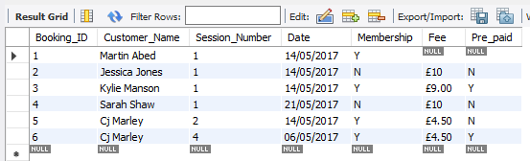

Figure 33: Booking List Table

## **G**



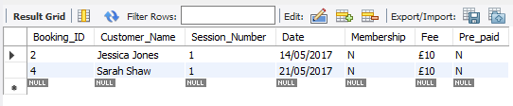

Figure 34: selecting all customers booked on session 1 who have not yet paid

## **H**



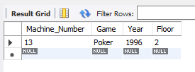

Figure 35: selecting all machines on floor 2 by year in descending order

## **I**



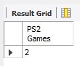

Figure 36: counting all the console games for the PS2

## **J**



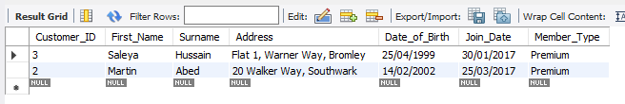

Figure 37: selecting all customers who have a premium membership in descending order of surname

## **K**



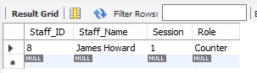

Figure 38:selecting all the staff working on session 1 on the counter

## **L**



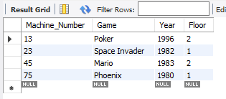

Figure 39: Updating the floor for Mario from floor 1 to floor 2

## **M**



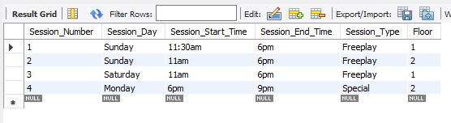

Figure 40: Updating the start time for session 1 to 11.30 am

## **N**



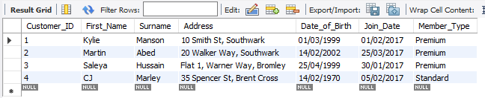

Figure 41: Updating the membership type from standard to premium for the customer ‘Kylie

## **O**



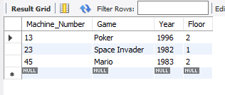

Figure 42: Deleting the machine Phoenix

## **P**



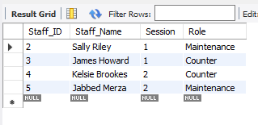

Figure 43: Deleting Gemma Hoyle from the staff rota for session 1